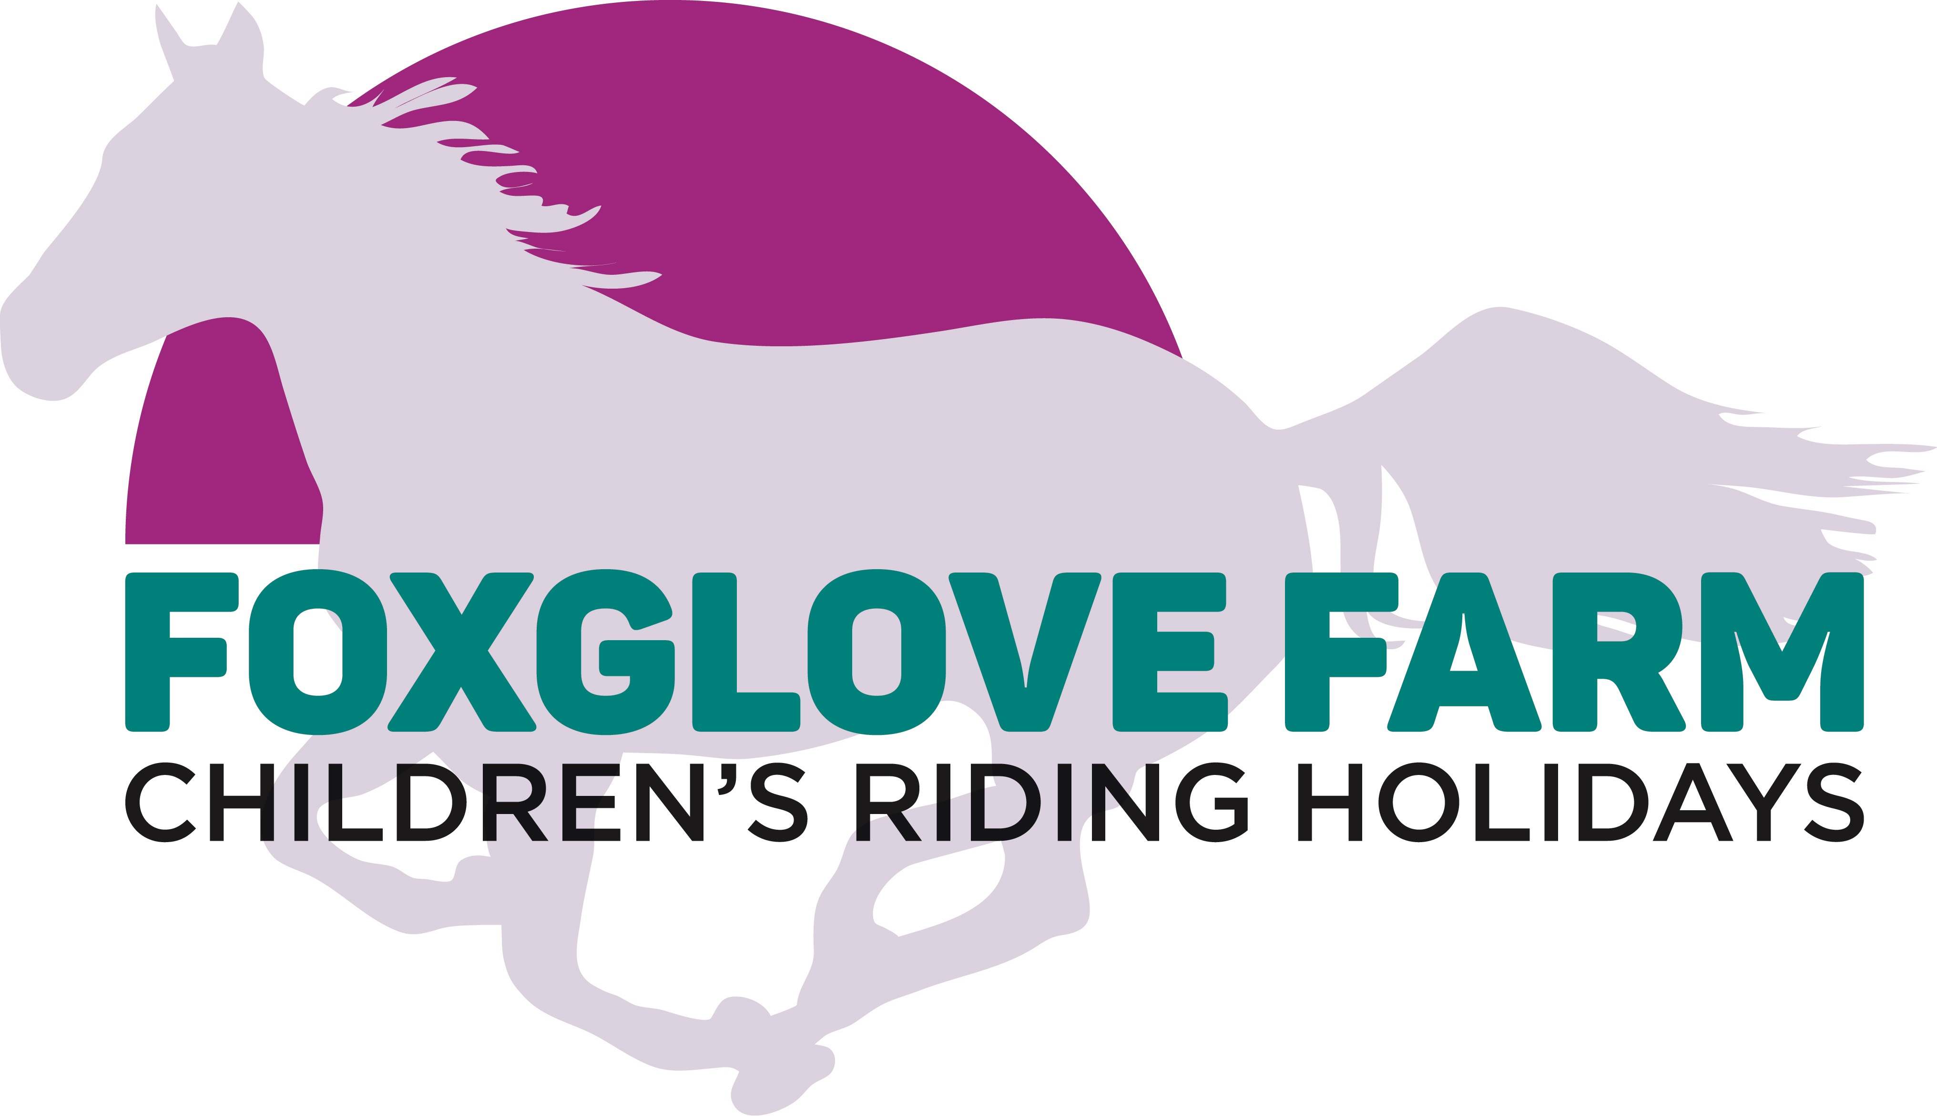
Foxglove Farm, Gibraltar, Nr Dinton, Buckinghamshire, HP17 8TY
For bookings or enquiries, please call Natasha on 07748 637 767 or 01296 747 686

Residential Registration and Consent Form
Child’s First Name: |  | Child’s Surname:
Address: | ………………………………………………………………………………………………  ………………………………………………………………………………………………
Home Telephone No: |  | Mobile No:
Emergency
Numbers:
Date of Birth: |  | Age:
Height: |  | Weight:

RIDING ABILITY
Please be as accurate as possible and tick all applicable boxes.
I consider myself (or the person for whom I am signing on behalf of as a minor) to:
Never ridden before ◻ Beginner ◻ Novice ◻ Intermediate ◻ Advanced ◻
How many times have you ridden in the last twelve months:
None ◻ Under 12 ◻ 12 – 40 ◻ 40+ ◻
What do you believe yours or the persons riding capabilities on a horse or pony to be?
Riding at walk ◻ Trotting with stirrups ◻ trotting without stirrups ◻ Cantering ◻
Hacking ◻ Jumping up to 50 cm ◻ Jumping up to 75cm ◻ Jumping up to 1m ◻
Riding around a cross country course ◻ Competing in a specific discipline ◻
Please describe the type of ponies/horses you typically ride, e.g. size, temperament etc.
Has your child ever suffered serious injury or discomfort whilst riding or been advised not to ride? Yes / No
Please detail ANY medical conditions that may affect your child’s ability to ride or carry out yard activities?
I accept that my child rides at his/her own risk.
Data Protection Act 1998 Statement: I understand that the information I have been given will be held in accordance with the Data Protection Act 1998 but may also be made available to insurers and other concerned parties in the event of injury or accident. I understand that I must obey the instructions of the staff and instructors and must comply with the Health and Safety requirements of the establishment.
I confirm that to the best of my knowledge all of the details on this form are correct.
In the event of accident, I will allow the establishment to check over my child and administer first aid if necessary. If I remove my child, this is entirely at my own risk.
I acknowledge that riding and being at a yard around horses is a dangerous sport and activity and holds potential danger. All horses and ponies may react unpredictably on occasions.
If you remove your child from the residential riding school at any point during the holiday, the full amount is still chargeable.
Do you have any objections to your child being photographed during the holiday or riding activities to help build their riding portfolio? There is a possibility that these photos will be published in a Hartwell Riding Stables brochure, Foxglove Farm brochure, on their website and on Facebook. Yes / No
Please be aware that all personal possessions brought to Foxglove Farm and Hartwell Riding Stables are left completely at your own risk. Foxglove Farm Residential Riding Holidays and Hartwell Riding Stables will not accept responsibility in the event of accident or loss.
……………………………………………………………………………………………………………………………………………………………
……………………………………………………………………………………………………………………………………………………………

Please Initial

MEDICAL DETAILS AND CONSENT
Child’s Full Name:
Insurance Policy Provider
Policy Number
NHS Number:
GP Name: |  |  | GP Telephone No:
Allergies
Please give details of any known allergies, including details of reaction and treatment needed, if any.
Medical Conditions
Please state any medical conditions or disabilities that your child has. If none, please state “None”.
Medication
Please give details of any prescribed medication taken. If none, please state “None”.
Name of medication |  | Purpose | Dosage |  | Times given
What actions should be taken if a dose of the above is missed, refused, vomited etc., and therefore the full prescribed dosage is not administered? |  |  | …………………………………………………………………………………………………………………………………………………………
May we give your child Calpol or other paracetamol in the recommended dose if he/she has a headache or is unwell? If not, please state alternative action. |  |  | ……………………………………………………………………………  ……………………………………………………………………………
Needs
Please state any other dietary/medical conditions or needs not already detailed. If vegetarian or vegan, please state.
Medical Consent
In the event of my child needing any medical treatment whilst involved in a Hartwell Riding Stables Activity or Foxglove Farm Activity, I agree that Hartwell Riding Stables and Foxglove Farm Residential Riding Holidays may give consent for such treatment as seen necessary by a medical professional and whilst it is in the immediate best interest of my child’s well-being.
I further consent to the medication I have detailed being administered by Hartwell Riding Stables and Foxglove Farm Residential Riding Holidays. I undertake to provide clearly labelled appropriate medicine and will notify any changes to the medicine detailed on this form.
I confirm that I have read and understood all of the Terms and Conditions,as stated on the
Foxglove Farm Residential Riding Holidays website. www.foxglovefarm.co.uk/termsandconditions
Signature: |  |  | Date:
Parent/Guardian (Please delete as appropriate) |  |  | Print name:

Foxglove Farm, Gibraltar, Nr Dinton, Buckinghamshire, HP17 8TY
For bookings or enquiries, please call Natasha on 07748 637 767 or 01296 747 686

